# Assignment 3: Gathering, Scraping, Munging and Cleaning Data

**Sample data from every table.**

Student:

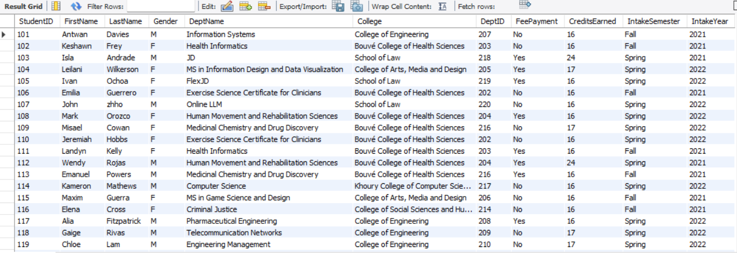

College:

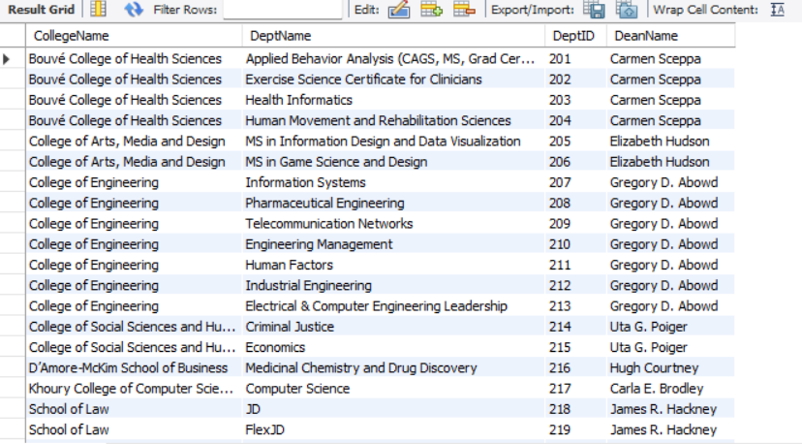

OnCampusEmployment:

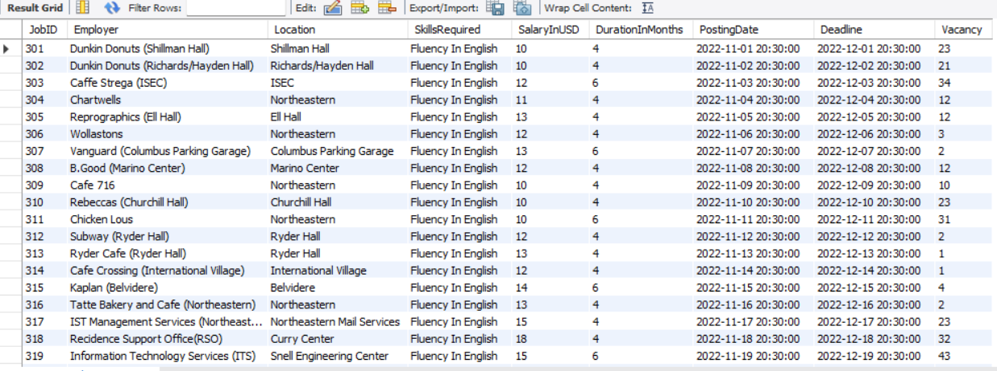

InternshipsAndCoop:

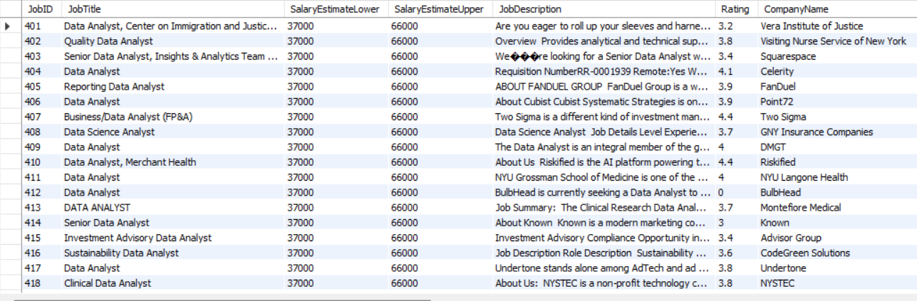

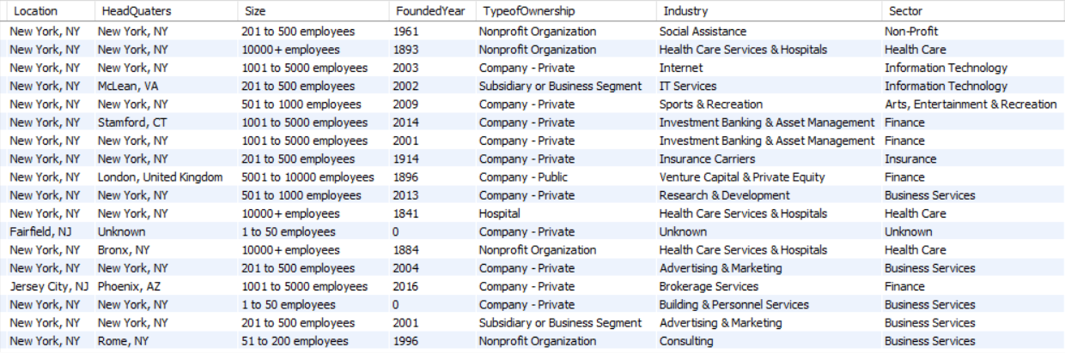

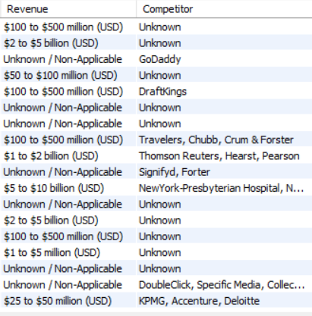

EventDetails:

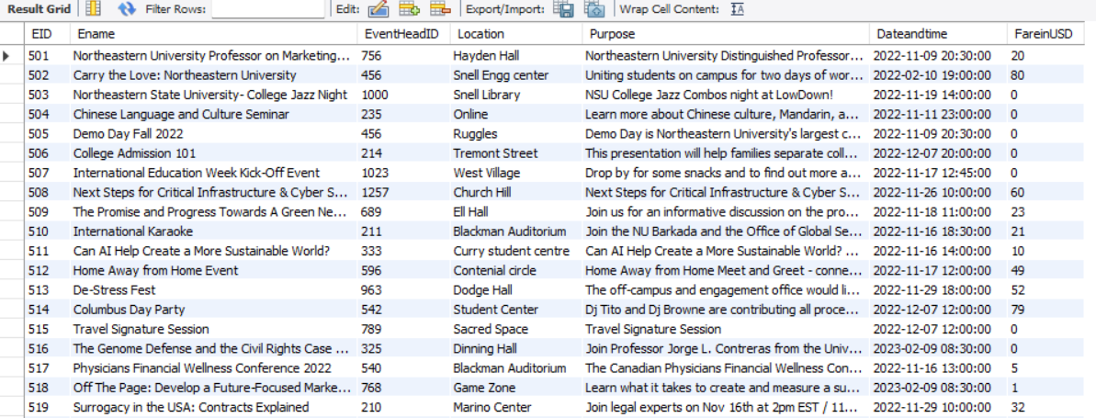

StudentClub:

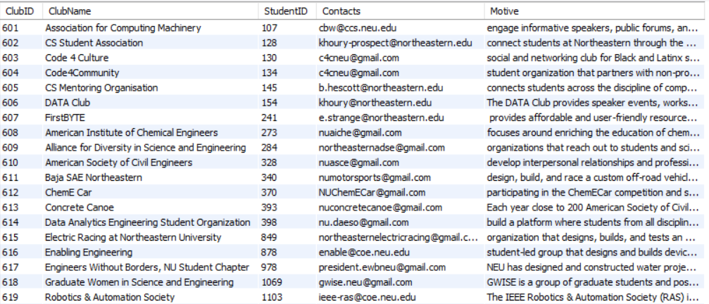

StudentOnCampus:

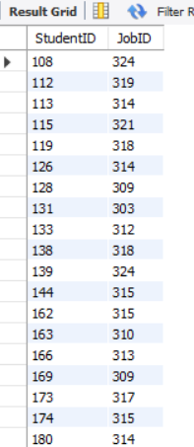

StudentJob:

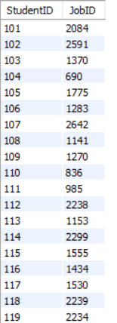

--------------------------------------------------------------------------------------------------------------------------

**SQL for all of your inserts and queries**

**CREATING TABLES:**

**Sudent:**

CREATE TABLE STUDENT (StudentID INT NOT NULL PRIMARY KEY, FirstName VARCHAR(50), LastName VARCHAR(50), Gender VARCHAR(5), DeptName VARCHAR (100), College VARCHAR(70), DeptID INT NOT NULL, FeePayment VARCHAR(5), CreditsEarned INT, IntakeSemester VARCHAR(10), IntakeYear INT);

INSERT INTO STUDENT (StudentID, FirstName, LastName, Gender, DeptName, College, DeptID, FeePayment, CreditsEarned, IntakeSemester, IntakeYear) VALUES(1951, "Joshua", "Lewis","M","Information Systems", "College of engineering", 201, "Yes",8, "Fall", 2022);

select * from STUDENT WHERE FirstName = "Joshua";

**College:**

CREATE TABLE COLLEGE (CollegeName varchar(100) NOT NULL, DeptName varchar(100) NOT NULL, DeptID INT NOT NULL PRIMARY KEY, DeanName varchar(100)NOT NULL);

**OnCampusEmployment:**

CREATE TABLE OnCampusEmployment (JobID int NOT NULL PRIMARY KEY, Employer VARCHAR(100) NOT NULL, Location VARCHAR(100) NOT NULL, SkillsRequired VARCHAR(100) NOT NULL, SalaryInUSD INT NOT NULL, DurationInMonths VARCHAR(100), PostingDate DATETIME, Deadline DATETIME, Vacancy INT);

**InternshipsAndCoop:**

CREATE TABLE InternshipsAndCoop (JobID INT NOT NULL PRIMARY KEY, JobTitle varchar(500), SalaryEstimateLower INT, SalaryEstimateUpper INT, JobDescription varchar(1000), Rating FLOAT, CompanyName VARCHAR(500), Location VARCHAR(500), HeadQuaters VARCHAR(500), Size varchar(100), FoundedYear INT, TypeofOwnership VARCHAR(500), Industry VARCHAR(500), Sector VARCHAR(500), Revenue VARCHAR(500), Competitor VARCHAR(100));

**EventDetails:**

CREATE TABLE EventDetails (EID Int NOT NULL PRIMARY KEY, EName varchar(100), EventHeadID INT NOT NULL, Location varchar(50), Purpose varchar(1000), Dateandtime datetime, FareinUSD int);

**StudentClub:**

Create TABLE StudentClub (ClubID int NOT NULL primary KEY, ClubName Varchar(100), StudentID INT NOT NULL, Contacts Varchar(100), Motive varchar(1000));

**StudentOnCampus:**

CREATE TABLE StudentOnCampus(StudentID INT NOT NULL PRIMARY KEY, JobID INT);

**StudentJob:**

CREATE TABLE StudentJob (StudentID INT NOT NULL, JobID int NOT NULL);

--------------------------------------------------------------------------------------------------------------------------

**# Assignment3 Questions**

**#1 Display the count of students in each department**

SELECT s.DeptName, Count(FirstName) FROM Student s INNER JOIN College c ON s.DeptID=c.DeptID GROUP BY s.DeptID, c.DeptID ORDER BY Count(FirstName);

**Output:**

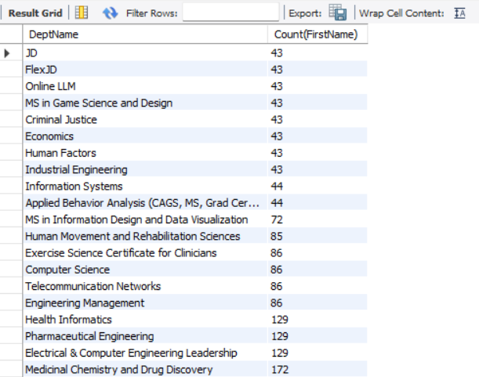

**#2 Which college has more number of student head?**

SELECT College,Count(College) AS NumberOfStudentHeads FROM Student s INNER JOIN StudentClub sc ON s.StudentID=sc.StudentID GROUP BY s.College ORDER BY College;

**Output:**

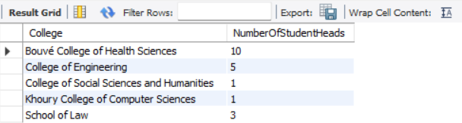

**# Example for question 2**

SELECT College, s.StudentID FROM Student s INNER JOIN StudentClub sc ON s.StudentID=sc.StudentID WHERE s.College="School of Law";

**Output:**

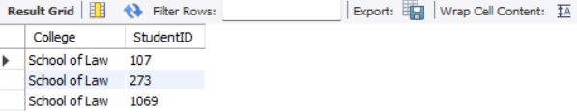

**#3 Number of students who got coop**

SELECT sj.JobID, COUNT(s.StudentID) AS NumberOfStudents FROM Student s INNER JOIN StudentJob sj ON s.StudentID=sj.StudentID GROUP BY sj.JobID ORDER BY JobID;

**Sample Output:**

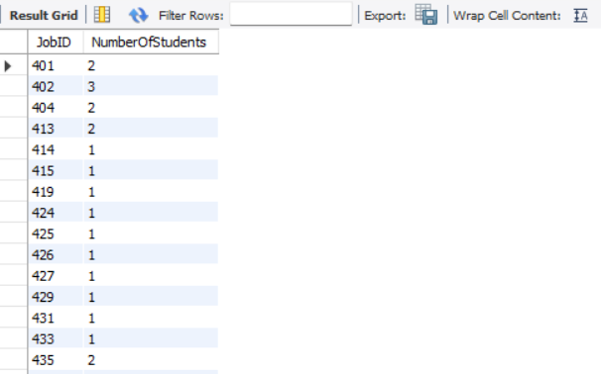

**#4 Which department got maximum placements?**

SELECT s.DeptID, s.DeptName, COUNT(sj.JobID) AS NumberOfStudents FROM Student s INNER JOIN StudentJob sj ON s.StudentID=sj.StudentID GROUP BY s.DeptID ORDER BY COUNT(sj.JobID) DESC;

**Output:**

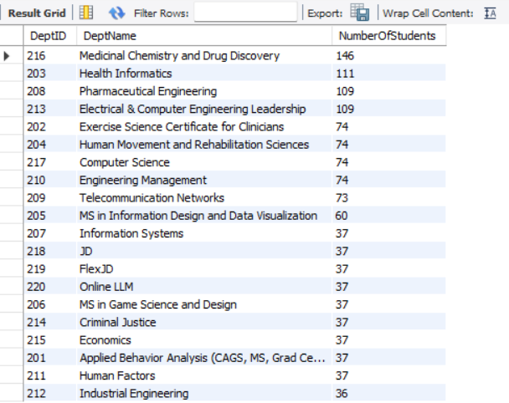

**#5 Average salary offered to students in each department**

SELECT s.DeptName, AVG(i.SalaryEstimateUpper) AS Average FROM Student s INNER JOIN StudentJob sj ON s.StudentID = sj.StudentID INNER JOIN InternshipsAndCoop i on sj.JobID = i.JobID GROUP BY s.deptname;

**Output:**

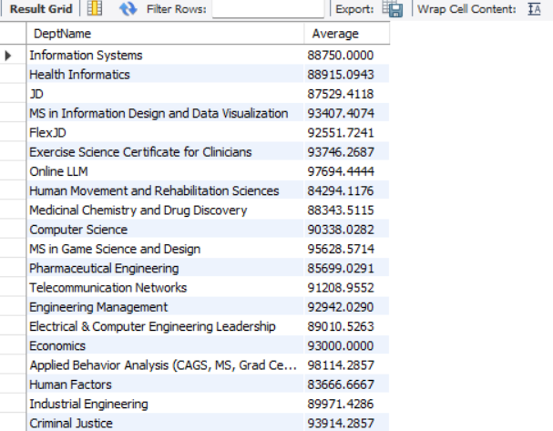

**#6 Maximum number of JobOpenings**

SELECT JobID, JobTitle, MAX(mycount) AS Maximum_Number_Of_Job_Openings FROM (SELECT COUNT(JobTitle) mycount, JobTitle, JobID FROM InternshipsAndCoop GROUP BY JobTitle) as sample;

**Output:**

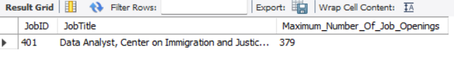

**#7 Job Count for each intake**

SELECT s.IntakeSemester, s.IntakeYear, COUNT(sj.StudentID) FROM Student s INNER JOIN StudentJob sj ON s.StudentID=sj.StudentID GROUP BY s.IntakeSemester, s.IntakeYear;

**Output:**

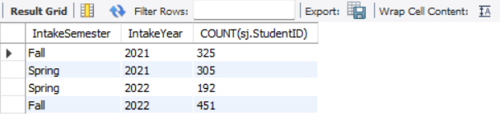

**#8 Booming Industry**

SELECT ic.Industry, COUNT(ic.Industry) BoomingIndustry FROM InternshipsAndCoop ic INNER JOIN StudentJob sj ON ic.JobID=sj.JobID GROUP BY ic.Industry ORDER BY COUNT(ic.Industry) DESC;

**Sample Output:**

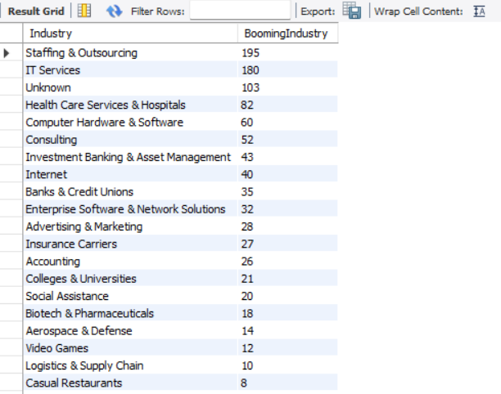

**#9 Which Second Highest Salary**

SELECT MAX(SalaryEstimateUpper) AS Second_Highest_Salary from InternshipsAndCoop WHERE SalaryEstimateUpper < (SELECT Max(SalaryEstimateUpper) FROM InternshipsAndCoop);

**Output:**

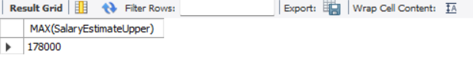

**#10 Students who got internship and oncampus**

SELECT sj.StudentID FROM StudentOnCampus soc INNER JOIN StudentJob sj ON soc.StudentID=sj.StudentID;

**Sample Output:**

